Quebec Hall Ltd
(Home for Retired Christians)
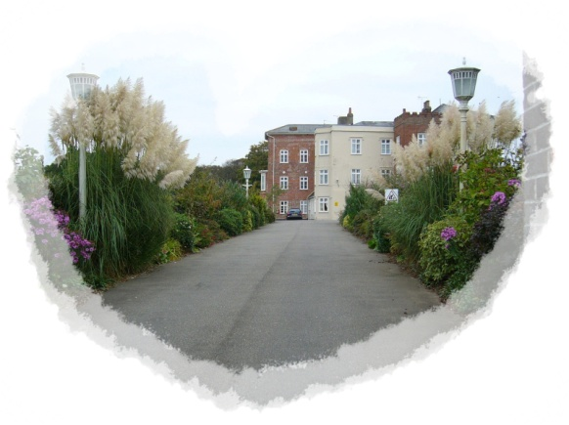
CONFIDENTIAL
Application for Residential Accommodation
Date of Application.................................................................................................................................................
Title (Mr/Mrs/Miss/Dr/Rev etc).............Full names...........................................................D.O.B............................
Current address......................................................................................................................................................
................................................................................................................................................................................
Telephone number.................................................Mobile Number.......................................................................
Email address (if any) .............................................................................................................................................
If your application for residency is accepted, do you have independent financial means to fund your place at Quebec Hall, or would you require full/partial Government funding?
..................................................................................................................................................................................
(If you require financial assistance, we will need to see a written statement from the Social Services department of the county council or other statutory authority under whose jurisdiction you currently reside. This Social Services statement will need to contain an agreement that the authority concerned is prepared to pay your care fees).
Please provide the names and addresses of two people who can provide references on your behalf
Referee 1.................................................................................................................................................................
..........................................................................................................................................................................................
Referee 2........................................................................................................................................................................
...........................................................................................................................................................................................
(Please turn over)

Please enclose a report from your GP, detailing your present health and your health needs. All details will be held in strict confidence.
As the heading at the top of Page 1 of this form indicates, one of Quebec Hall’s primary objectives is to provide a residential facility for retired Christians. This means that Quebec Hall provides a facility where men and women with a Christian faith can live alongside like-minded people and are given the opportunity to share times of prayer, worship and fellowship with one another. We realise that not all applicants share those values – but we would like to know if you would feel comfortable in an environment with that practice and ethos.
(Please cross out which of the two responses below does not represent your position)
1 Yes I am comfortable with the Christian faith-based foundations and ethos of Quebec Hall
2 No I am not comfortable with the faith-based foundations and ethos of Quebec Hall
If you have indicated above that you are comfortable with the Christian foundations and practices of Quebec Hall, we would be delighted if you would give us a brief account of the part Christian faith has played in your life, along with details of any Christian fellowship you currently attend or hold membership. If the Christian foundations and practices of Quebec Hall do not form part of the reason why you have applied to Quebec Hall for residential accommodation, please mark N/A or Not Applicable’ in the space below.
............................................................................................................................................................................................
........................................................................................................................................................................................
...........................................................................................................................................................................................
.........................................................................................................................................................................................
..........................................................................................................................................................................................
............................................................................................................................................................................................
............................................................................................................................................................................................
................................................................................................................................................................................
(you may continue on another sheet of paper if you wish)

Signed........................................................................................
Name (please print).............................................................. Date......................................................
Please return this completed application form to
Mr Mark Woodgett, General Manager, Quebec Hall, Quebec Road, Dereham, Norfolk NR19 2QY
PERSONAL DATA FORM – Quebec Hall Ltd Residents, bungalow residents, family members, employees, trustees, tradesman and third parties,
Confidential
To
From | Quebec Hall Ltd.
Date
Personal data
By signing below you agree that Quebec Hall Ltd. Can hold your personal data on our computer and to have paper copy information similar to that held on our computer and to have your email details.
Will you please inform us whenever your details change so that we can insure the information we have is correct and up to date. Please return this slip to Karen or Mark within seven days.
Signature

